Data structures and Algorithms
Exercise 2: E-commerce Platform Search Function
- Explain Big O notation and how it helps in analysing algorithms.
Big O notation is a mathematical way to describe how the running time or memory usage of an algorithm grows as the input size (n) increases.
It focuses on the worst-case growth rate and ignores constant factors and lower-order terms.

Common Big O Complexities
Big O | Name | Example
O(1) | Constant Time | Accessing an array element
O(log n) | Logarithmic Time | Binary Search
O(n) | Linear Time | Linear Search
O(n log n) | Linearithmic Time | Merge Sort
O(n²) | Quadratic Time | Nested Loops

Big O Helps in analysing Algorithms:
Measures Efficiency: Shows how an algorithm performs as data size grows.
Compares Algorithms: Helps choose the faster algorithm for large datasets.
Predicts Scalability: Indicates whether an algorithm will remain practical for very large inputs.
Ignores Hardware Differences: Focuses on algorithm behaviour rather than processor speed or memory.
Helps Optimize Programs: Identifies inefficient parts of code and guides improvements.

- Describe the best, average, and worst-case scenarios for search operations.
Linear Search
- Best Case: O(1) >> Element found at the first position.
- Average Case: O(n/2) ≈ O(n) >>Element found somewhere in the middle.
- Worst Case: O(n) >>Element found at the last position or not present.
Binary Search
- Best Case: O(1) >>Element found at the middle position.
- Average Case: O(log n)
- Worst Case: O(log n):Search space repeatedly divided until one element remains.
- Implement linear search and binary search algorithms.
Store products in an array for linear search and a sorted array for binary search.
Product.cs
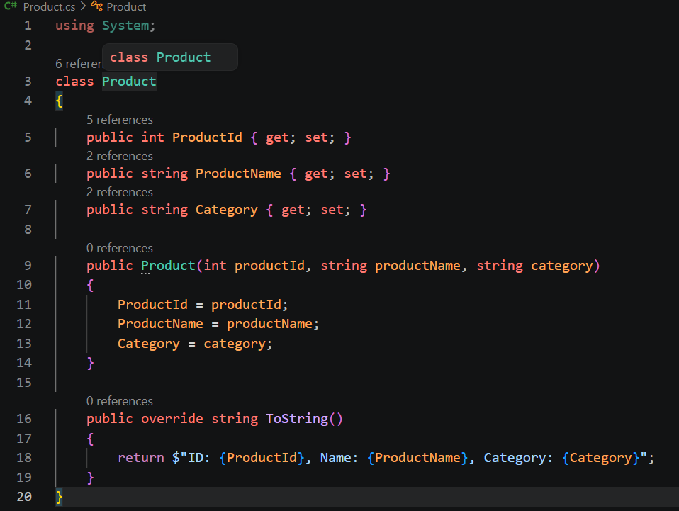
LinearSearch.cs
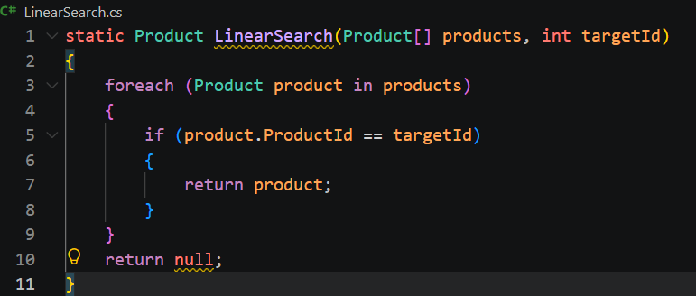
BinarySearch.cs
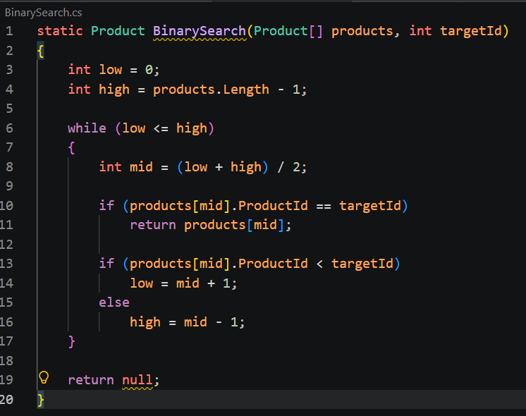
Output :
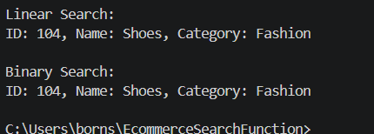
Analysis
Time Complexity Comparison
Algorithm | Best Case | Average Case | Worst Case
Linear Search | O(1) | O(n) | O(n)
Binary Search | O(1) | O(log n) | O(log n)
- Which Algorithm is More Suitable?
Binary Search is more suitable for an e-commerce platform because:
- It is much faster for large datasets.
- It reduces the search space by half in every iteration.
- For millions of products, it requires far fewer comparisons than Linear Search.
Linear Search is suitable only when:
- The data is unsorted.
- The number of products is small.

Conclusion
For a real e-commerce platform containing thousands or millions of products, Binary Search is the preferred choice because its time complexity is O(log n), making product searches significantly faster than Linear Search (O(n)).

Exercise 7: Financial Forecasting
- Explain the concept of recursion and how it can simplify certain problems.
Recursion is a programming technique where a method calls itself to solve smaller instances of the same problem until a base case is reached.
Why Use Recursion?
- Simplifies problems that can be broken into smaller subproblems.
- Makes code easier to understand for mathematical calculations.
- Commonly used in:
- Factorial calculations
- Fibonacci series
- Tree traversal
- Financial forecasting
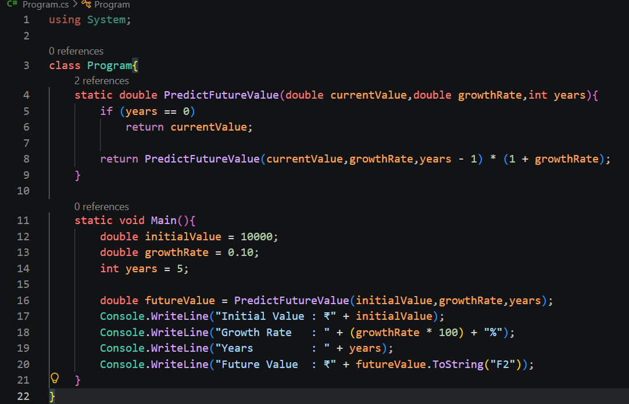
Output :
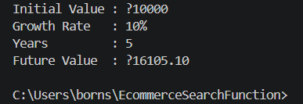
Time Complexity
Let n be the number of years.
The recursive method makes one recursive call per year.
T(n) = T(n-1) + O(1)
Therefore:
Time Complexity = O(n)
Space Complexity
Each recursive call is stored in the call stack.
Space Complexity = O(n)

5. Optimization
Problem with Large Inputs
For very large values of n:
Predict Future Value (10000, 0.10, 10000);
the recursion depth becomes large and may cause:
- Excessive memory usage
- Stack Overflow Exception

